**C++ Project : Vaccine Management System**

**Submitted By:**

**SP0217**

Members:

1. Sakshi Vashishtha

2. Simran Bharadwaj

3. Sunil Bharti

4. Priyansh Devpura

5. Divyanshu Parihar

* ***Overview* :** The project Vaccine Management System aims to efficiently store, display and delete data of vaccinated people. The project is built using C++ programming language and is a simple console application. Various concepts of C++ such as Object Oriented Programming and File handling have been extensively used to provide different functionalities to the project and a smooth experience for the user.

In this project, the user is provided with an interface to access multiple functionalities. It allows the user to store their personal information on the computer system, view a list of people vaccinated, access the information they have entered through their aadhar number, download their certificate and also enables them to delete their record. File handling has been effectively used to perform all these tasks. The project even provides a feature of login and password to secure the data of all users.

* ***Header Files Used***

1. **#include<iostream>** iostream provides basic input and output services for c++ programs. Iostream uses the objects cin, cout, cerr, and clog for sending data to and from the standard streams input, output, error and log respectively.
2. **#include<fstream>** It is used to create files, write information to the files and read information from the file.
3. **#include<stdlib.h>** This header file is for the general purpose standard library of C++ programming language which includes functions having memory allocation, process control, conversions and others.
4. **#include<cstdlib>** This header file declares a set of general purpose functions such as: atof() to convert string to double. It also contains a few mathematical functions such as abs() to find the value of a number.
5. **#include<conio.h>** conio.h is the abbreviation for Console Input Output Header File. This is useful because this declares several functions for performing “istream input and output” from a program.
6. **#include<string>** This header file is required for the string functions. This header file defines one variable type, one macro and various functions for manipulating strings.
7. **#include<windows.h>** This is a special header file as this contains the declarations for all the functions in the Windows API, all the common macros used by the Windows programmers, and all the data types used by the various functions and subsystems.
8. **#include<time.h>** This header file contains time and date function declarations to provide standardized access to the time/date manipulation and formatting.

* ***Some of the functions of our code and their work :***

1. Login() : This function asks the user to enter their name and aadhar number and in turn creates an account for the user to which they can login using the same credentials. Access to the menu interface is only granted when the user enters correct details along with a captcha code displayed on the screen.

1. Menu() : The Menu function enables the user to make a choice of the task they want to execute and leads them to the interface of that option.

1. Insert() : The Insert function allows the user to enter their personal information to be stored in the txt file.

1. Display () : The display function shows a list of vaccinated people present in the txt file along with the vaccine injected.

1. Download () : This is used to download the Vaccine Certificate of the user and the certificate is then sent to the user's email.

1. Delete () : The delete function asks the user for their aadhar number and then erases all the information present in the file for the entered aadhar number.

1. Search () : This function, when called, asks the user to enter their aadhar number and then displays the information stored in the file corresponding to the aadhar number entered

* ***Output*:**

When the program is run, the user is welcomed to the sign-up page, where he can sign up with their name and aadhar number. Then the user is taken to the login page, where they need to login with the same credentials and enter the correct captcha.

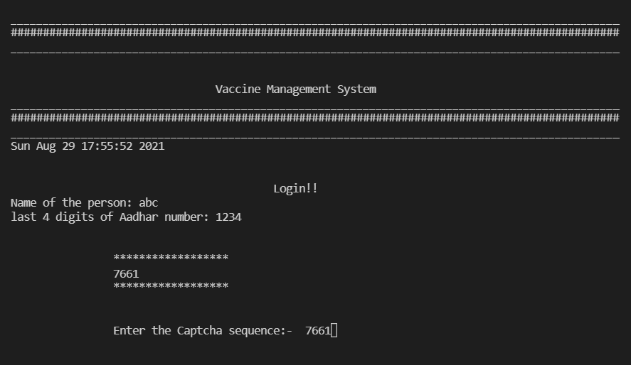

Once the correct captcha is entered, the user is navigated to the main menu. It is the principal part of our program. It contains all the functionalities and main operations of our program.

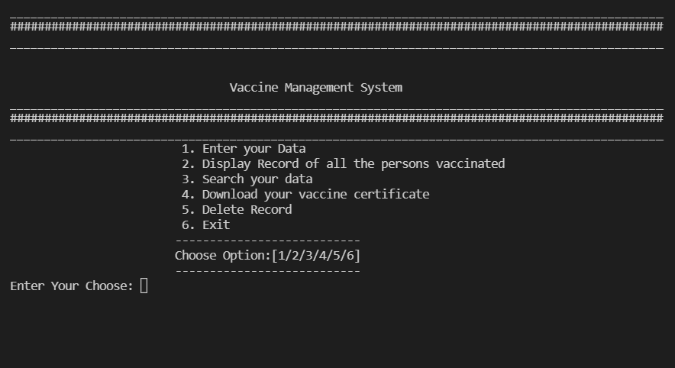

1. Enter your data-

This adds details of the new users into the binary file (named personRecord.txt)

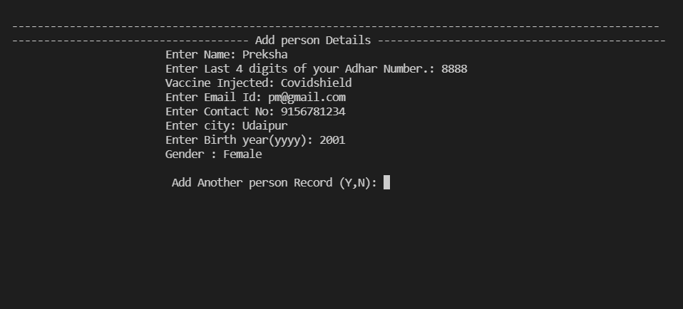

1. Display records of all the person vaccinated-

Retrieves and displays data (name and vaccine injected) present in the file(personRecord.txt)

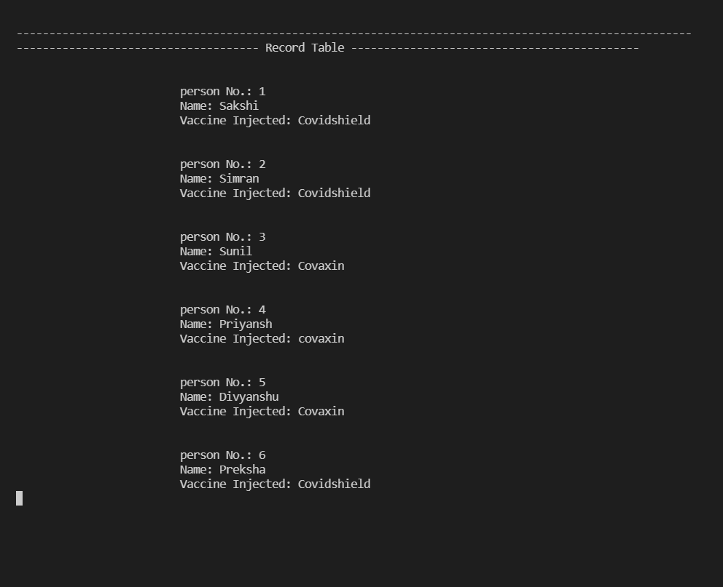

1. Search your Data-

This fetches and displays all the data of a particular user from the file.

Searching is done on the basis of Aadhar Number.

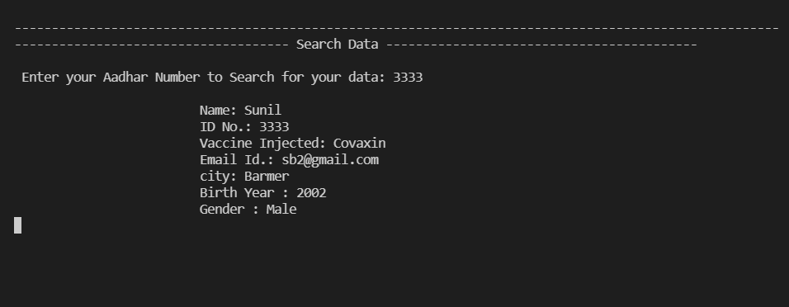

1. Delete Record-

If the user has entered something wrong or wishes to delete their data, they can do that by using this functionality.

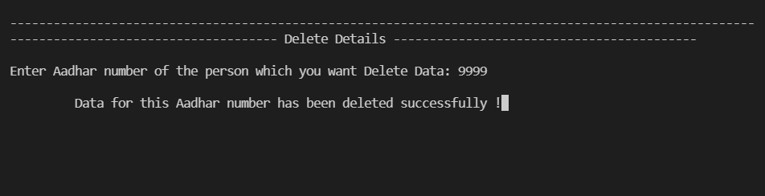

**THANK YOU**